**Personal details**

|  |  |
| --- | --- |
| **Name** |  |
| **Address** |  |
| **Phone number:** |  |
| **How did you hear of us?** |  |

**Health History**

|  |  |
| --- | --- |
| **Please list any allergies you have (including cosmetics/ ingredients):** |  |
| **Have you ever had a reaction to cosmetics, topical creams, botanical products, or other skincare products?** | Yes  No |
| **Do you have a skin disease, condition or injury that may affect your makeup application?** | Yes  No  If yes, please list: |
| **Please list all current medications you are taking (including over-the-counter herbs, vitamins and supplements):** |  |
| **How would you categorise your skin type?** | Normal  Dry  Oily  Combination  Sensitive |
| **Do you want your makeup done for an event?** | Yes  No  If yes, please explain: |

|  |  |  |  |  |  |
| --- | --- | --- | --- | --- | --- |
| **Have you ever had or do you have any of these conditions?** | | | | | |
| Alopecia |  | Skin irritation |  | Sunburn |  |
| Impetigo |  | Dry Eye |  | Sensitive skin |  |
| Molluscum contagiosum |  | Watery eyes |  | Open wounds or cuts |  |
| Claustrophobia |  | Scabies |  | Psoriasis or eczema |  |
| Pigmentation disorders |  | Ringworm |  | Methicillin-resistant Staphylococcus aureus (MRSA) |  |
| Conjunctivitis |  | **Shingles** |  |
| Current eye irritation |  | Possible Pregnancy |  |
| Other  (please list): | | | | | |

|  |  |  |
| --- | --- | --- |
| Factors that may impact the service: | **Yes** | **No** |
| Are you pregnant or nursing? |  |  |
| Have you ever had a reaction to cosmetics? |  |  |
| Do you wear contacts? |  |  |
| Have you had facial treatments? |  |  |
| Have you had Botox or injections? |  |  |

Although every precaution will be taken to ensure your safety and wellbeing before, during and after your makeup application, please be aware of the following information and possible risks. Please initial each statement below:

| **Initial** | **Statement** |
| --- | --- |
|  | I understand that makeup services have some inherent risk of irritation to the skin should an allergic reaction occur. |
|  | I understand that this is a semi-permanent procedure, and the tan will begin to fade ( 5 to 7 days) as my skin cells shed. |
|  | I understand that I must disclose all of the information requested in the Client Profile/Health History. |
|  | I have cited all conditions and circumstances regarding my health history, medications being taken, and any past reactions to products or medications. |
|  | I understand that additional conditions could occur or be discovered during the procedure, which could affect my ability to tolerate the procedure. |
|  | I consent to ‘before and after’ pictures for the purpose of documentation, potential advertising and promotional purposes. |
|  | I understand that skin preparation and aftercare are essential to the quality and longevity of the makeup. |

I understand the procedure and accept the risks. I do not hold the makeup artist, whose signature appears below, responsible for any of my conditions that were present but not disclosed at the time of this procedure, which may be affected by the treatment performed today.

|  |  |
| --- | --- |
| Client name: |  |
| Client signature: |  |
| Date: |  |

|  |
| --- |
| **MUA only** |

**Skin determination**

|  |  |
| --- | --- |
| **Type** | Normal  Dry  Oily  Combination  Sensitive |
| **Tone** | Fair  Medium  Dark |
| **pH level** | Balanced  More acidic  More alkaline |

**Selected products**

|  |  |
| --- | --- |
| **Skin prep** |  |
| **Prime** |  |
| **Brows** |  |
| **Eyes** |  |
| **Lashes** |  |
| **Base** |  |
| **Contour** |  |
| **Blush** |  |
| **Highlight** |  |
| **Lips** |  |
| **Other** |  |

**Face chart**

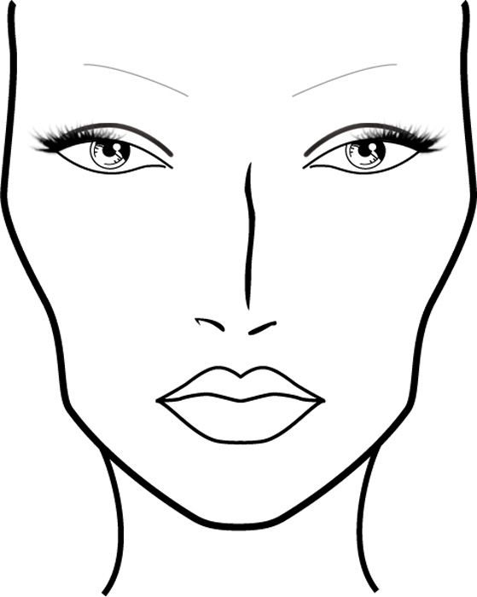

**Note any contraindications, contra-actions and other client-specific requirements:**

|  |
| --- |
|  |