The table below outlines common non-contagious contraindications relating to nail enhancement services, and a brief description as to why they are deemed as such. Some contraindications may not prevent treatment entirely; however, they will require additional safety measures to ensure the preservation of the health and safety of your client and/or yourself. These are labelled with an asterisk (*) and the additional requirement discussed in the description. This website has over 100 contraindications for manicures and pedicures, so you may like to do more research if you come across a contraindication you are unsure of Contraindications A-Z
Contraindication | Overview | Example
*Beau’s lines | Beau's lines are indentations that run across the nails. The indentations can appear when growth at the nail matrix is interrupted by injury or severe illness. Beau's lines can be caused by trauma or local disease involving the nail fold. Usually, the cause of Beau’s lines is injury or severe illness, but in some cases, environmental factors may be to blame. Although Beau’s lines can be associated with some serious health problems, they’re not contagious in any way.  Typical manicure and pedicure services should be fine for clients with Beau’s lines; and however, if your client has not sought medical attention for the diagnosis, this should be done prior to any treatments. If you were to cover up these lines with gel or acrylic nail enhancements, doctors would be unable to determine how long ago the matrix was affected and whether the lines could be because of an injury, so never cover them up until medical advice is sought! | 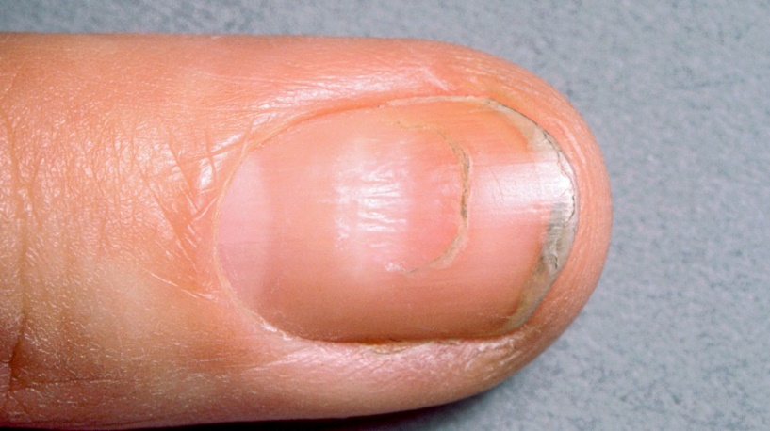
*Blisters | Blisters are an area of skin covered by a raised, fluid-filled bubble. Blisters can have causes that aren't due to underlying disease, and examples include burns, friction injuries or trauma. Blisters can also be a symptom of hand-foot-and-mouth disease, which is a mild, contagious viral infection. If a client has a blister that is non-contagious, you may be able to work around the area. If in doubt, do not proceed with treatment until it is healed. | 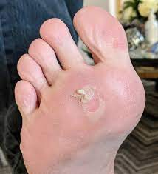
*Bruised nails | Subungual hematoma is the medical term for bleeding and bruising under the nail. This is usually the result of some kind of injury to the blood vessels under the nail bed. For example, blood vessels can break and leak blood into the area underneath the nail when a door slams on a finger or a heavy object crushes a toe.  Once the discoloured, bruised, or infected nail has been properly diagnosed by a doctor and treated, it is then safe to work on that client, provided there is no sign of infection, bleeding, pain, or allergy to acrylic. | 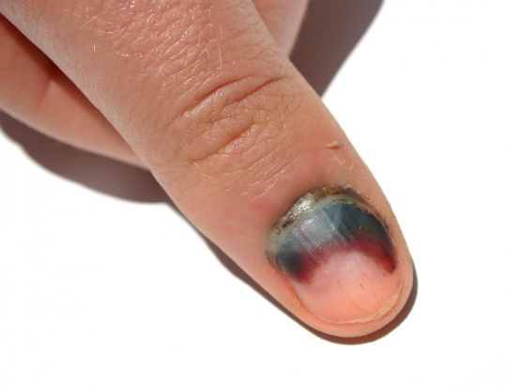
Bunions | A bunion is a bony bump that forms on the joint at the base of the big toe. It occurs when some of the bones in the front part of the foot move out of place. This causes the tip of the big toe to get pulled toward the smaller toes and forces the joint at the base of the big toe to stick out.  It's safe to perform a pedicure when a client is suffering from bunion pain. In fact, due to the soothing and relaxing nature of pedicures, they can provide relief from pain caused by bunions. | 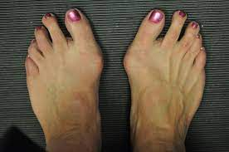
Calluses | A callus is an area of thickened skin that forms as a response to repeated friction, pressure, or other irritation. Calluses can have causes that aren't due to underlying disease. Examples include poorly fitting shoes, frequent use of tools or instruments, frequently walking barefoot or frequent friction to an area of skin. During a pedicure treatment, you can help to treat existing calluses, using a pumice stone or foot file to clear some dead skin off without being harsh. | 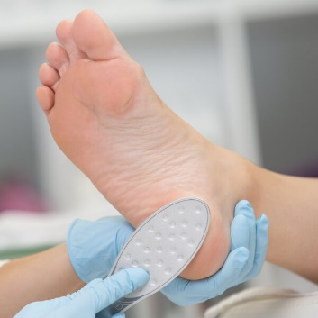
*Circulatory problems | Poor circulation isn’t a condition in itself. Instead, it results from other health issues. Therefore, it’s important to treat the underlying causes rather than just the symptoms. Several conditions can lead to poor circulation. The most common causes include obesity, diabetes, heart conditions, and arterial issues. The most common symptoms of poor circulation include:  - Tingling  - Numbness  - Throbbing or stinging pain in your limbs  - Pain  - Muscle cramps  Some nail technicians refuse to perform pedicures on clients with circulatory disorders or diabetes because they fear causing an infection. Although the procedure must be done with extreme care, pedicures can be very beneficial for these clients. | 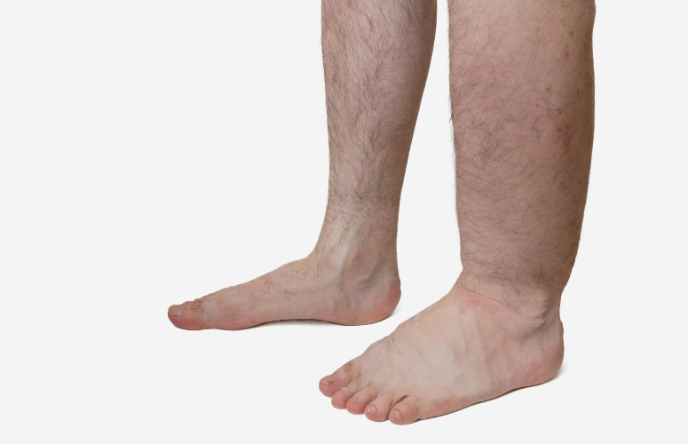
Corns | Corns and calluses are thick, hardened layers of skin that develop when your skin tries to protect itself against friction and pressure. They most often develop on the feet and toes or hands and fingers. Corns and calluses can be unsightly.  While it's generally safe to service clients with corns, nail techs should recommend that they see a podiatrist if their corns become very painful or inflamed or inhibit their daily life. | 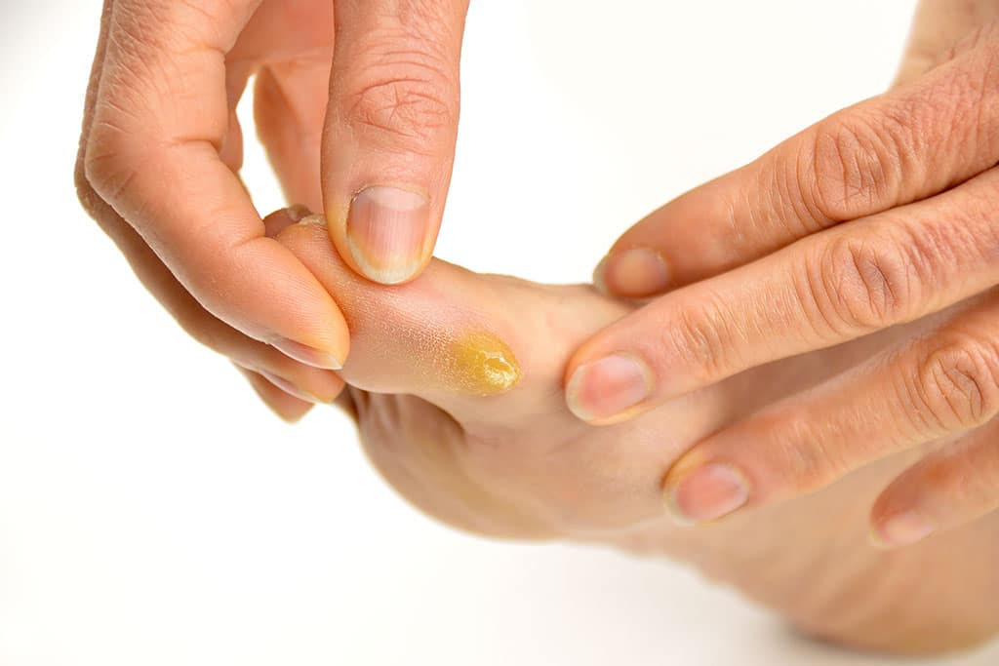
*Corrugated furrows | Also known as corrugations, corrugated furrows are long ridges that run either lengthwise or across the nail. Some lengthwise ridges are normal in adult nails, and they can increase with age.  Corrugated furrows may be caused by conditions such as psoriasis, poor circulation, and frostbite. If your client has other symptoms like colour or texture changes in your nails, it may be caused by a medical condition. Some nail technicians refuse to perform services on clients with ridges. Services can be provided once the nail has been properly diagnosed by a doctor and treated. When managing ridges, you can complete a light buffing, and you may want to use a ridge filler prior to applying polish will help to provide a smoother polish application. | 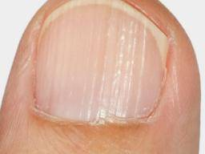
*Dermatitis | Hand and foot dermatitis is a dermatitis affecting the hands and/or feet. It can be due to contact dermatitis (allergic or irritant) or atopic dermatitis. Contact dermatitis occurs as a result of actual contact with an allergen or irritant. A good example of allergic contact dermatitis is a rash that develops after contact with the acrylates present in nail enhancement products.  While red, irritated skin may indeed be dermatitis, if you spot these symptoms on a client’s skin, don’t assume that’s what you’re looking at. You should not perform services until the irritated skin has been assessed by a professional. Most clients will not even come in for a mani or pedi if they have any type of dermatitis, but if they do, they should be gently told that it would be best to wait until after the area is clear to receive a service. | 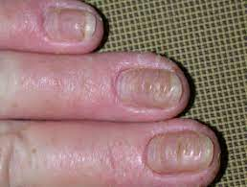
*Drug-induced nail changes | Drug-induced nail abnormalities result from toxicity to the matrix, the nail bed, the periungual tissues or the digit blood vessels. Drug-induced nail disease is diagnosed when a medication affects nail growth or structure. Drugs may cause:  - Changes to the shape of the nail (nail deformity)  - Changes in the texture or composition of the nail (nail dystrophy)  - Abnormality of the tissues around the nail (paronychia)  - Pigmentation of the nail plate  For mild changes, you may still be able to perform services with care. For any nails that appear to be abnormal, refer the client to a medical professional. | 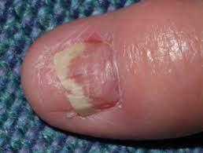
Eggshell nails | Another condition that can affect the nails is hapalonychia, sometimes called “eggshell nails.” Hapalonychia causes your nails to be soft and thin. Nails affected by this condition tend to bend or break more easily than healthy nails and often split or flake at the end. They may also take on a bluish tint.  There are several reasons a person may develop hapalonychia. These environmental factors, genetic conditions, nutritional deficiencies, diseases, medicines, and trauma. While most causes of hapalonychia may not cause severe or long-term harm to your health, there are also a few serious conditions that can cause hapalonychia.  Regularly applying lotion to clean hands can help keep nails healthy and moisturised. Filing, shaping, and trimming your nails on a daily basis can possibly help prevent hapalonychia. This condition is non-infectious and can therefore be manicured/pedicured. | 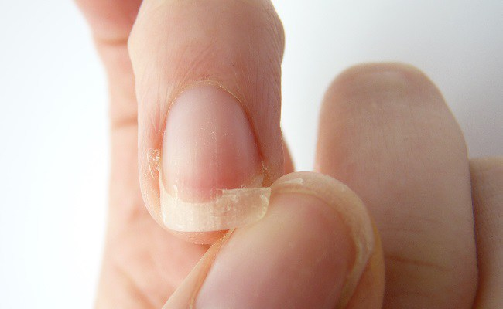
Habit tic | Habit-tic deformity is a condition of the nail caused by external trauma to the nail matrix. The condition is characterised by ridges that run horizontally across the entire nail, most often occurring on the thumbs, as well as marked damage to or absence of cuticles. A habit tic is a condition that often is the result of nervous habits, including picking at, playing with, or stroking the nails constantly. You can service a client with a habit tic, being sensitive to the fact that she/he may not be able to easily quit this damaging habit. | 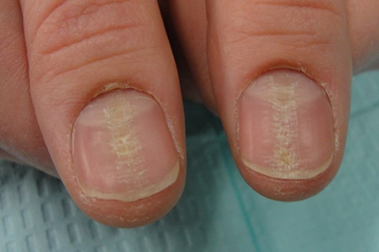
Hammertoes | A hammertoe is a deformity of the second, third or fourth toes. In this condition, the toe is bent at the middle joint so that it resembles a hammer. Initially, hammertoes are flexible and can be corrected with simple measures but, if left untreated, they can become fixed and require surgery. Servicing clients with hammertoe is typically safe, as long as there are no open lesions. When providing services to clients with hammertoes, consider the following tips:  - Implement extensive antiseptic practices to protect against unforeseen infections  - Use a gentle touch throughout the service  - Never use a corn remover to treat hammertoe  - Take proper precautions during the massage portion of a pedicure and never pull the toe straight  - Apply a massage oil or cuticle oil around the toe to reduce friction  Although not all cases of hammertoe are painful, symptoms typically include discomfort while walking, corns or calluses, inflammation and redness. | 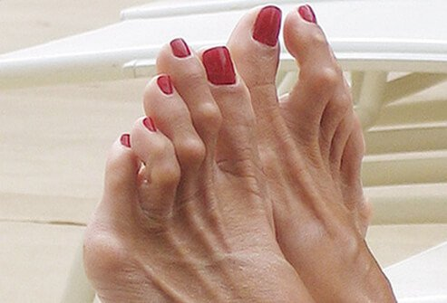  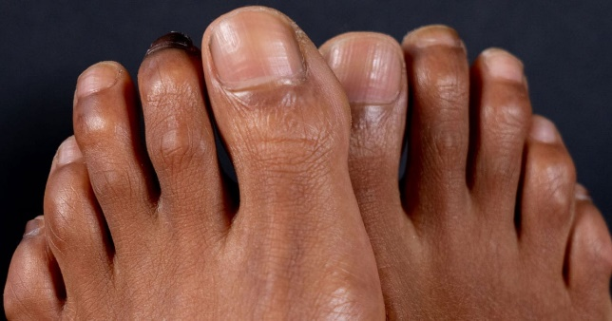
Hangnails | Hangnails are those irritating, jagged pieces of skin that stiffly jut out from around the sides of your fingernails. They rarely occur on toes. Despite their name, hangnails are not part of the nail itself. They may be small, but the pain, irritation, and discomfort hangnails cause is not.  Hangnails can result from a variety of things, like biting your nails, a bad manicure, dry skin, using harsh soap and detergents, cold temperatures, and 'waterlogged' hands. Sometimes hangnails can lead to inflammation of the cuticle (which is called paronychia), and topical steroids like 1% hydrocortisone or a prescription from a doctor may be needed. Hangnails should not be pulled ut; however, they can be trimmed during manicure services. This article has excellent information regarding hangnails and what you can say to clients to educate them: Something to Talk About: Hangnails | 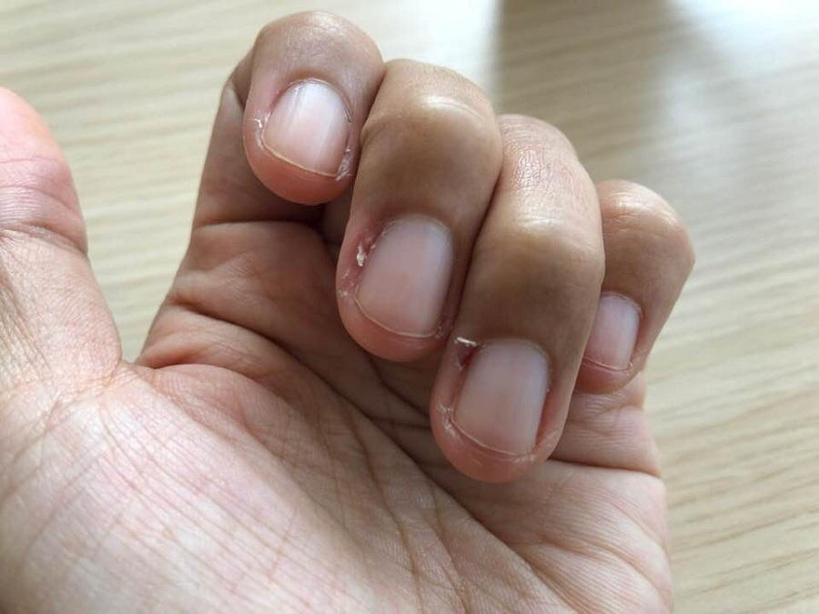
Heel fissures | Heel fissures, or cracked heels, happen when the skin on the bottom of your heel becomes hard and dry. You may also notice that the skin becomes flaky or crusty. When the skin gets very dry, cracks or fissures can form. Heel fissures can also lead to deep ulcers (open sores) that can get infected and result in cellulitis (a painful skin infection). That’s why preventing and treating heel fissures whenever possible is so important.  If the fissures are accompanied by pinkness (a sign of potential infection), redness or any indication of bleeding, the client should not receive a pedicure but rather be referred to a doctor. If you determine that the client can receive a service, a waterless pedicure is the treatment of choice. | 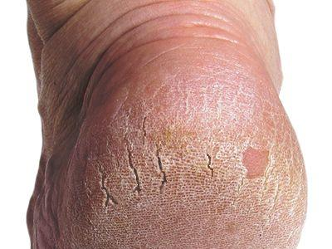
Koilonychias | Spoon nails (koilonychia) are soft nails that look scooped out. The depression usually is large enough to hold a drop of liquid. Often, spoon nails are a sign of iron deficiency anaemia or a liver condition known as hemochromatosis, in which your body absorbs too much iron from the food you eat. Koilonychia is not contagious, so treatments can be performed, but you must be gentle! | 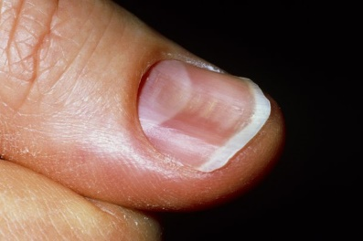
Onychauxis | Onychauxis is a nail disorder that causes fingernails or toenails to grow abnormally thick. Over time, the nails may become curled and turn white or yellow. This thickening of the nail may force the nail plate (the part you paint with nail polish) to separate from the nail bed. Onychauxis can be the result of a larger problem. You should encourage clients to have the nail assessed by a doctor before nail enhancements are applied.  A doctor will be able to determine the cause of discolouration and thickness. There may be damage to the nail bed, and it’s possible for you to break through the nail when filing. Depending on what’s going on under the nail, blood could squirt through when the nail is being thinned! Once a doctor has ruled out larger problems, such as a skin condition, fungus, or melanoma, you can have confidence that a manicure or pedicure, or the application of nail product, won’t harm the client. | 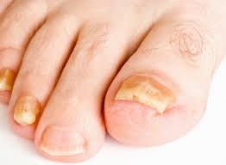
Onychocryptosis | Onychocryptosis, or ingrown nail, is a common condition in which the nail plate penetrates the nail fold, often resulting in inflammation and pain. A persisting ingrown toenail can have serious consequences. You must not manicure or pedicure if the infection is present. | 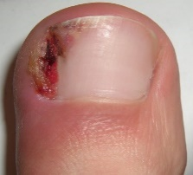
Onychophagy | Onychophagy is a term used to describe the habit of biting nails which, although it is most often associated with a condition affecting children and adolescents, is often also an adult problem. Onychophagia is defined as chronic nail-biting. This condition should be distinguished from onychotillomania, another form of self-induced destruction of the nails similar to onychophagia caused by recurrent picking and manicuring of the nails.  Treatment is not contraindicated unless the skin is broken. As nail techs, we see people regularly who have bitten their nails so badly the nails even look painful. Clients feel embarrassed and sometimes hopeless, but because nail biting is so common, it’s easy to dismiss it as just a nasty habit instead of the nail disorder that it is. Nail enhancements, manicures, or topical treatments may help the client stop biting their nails, but ultimately, it’s their own determination that allows there to finally stop biting their nails. | 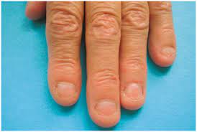
Onycholysis | Onycholysis is the separation of a fingernail or toenail from its pink nail bed. The separation occurs gradually and is painless. The most common cause of onycholysis is trauma. Onycholysis can affect a single nail or multiple fingernails and/or toenails. The distal part of the nail is most commonly affected lifting the free edge; sometimes, the nail may detach laterally or proximally.  Non-infectious nails can be manicured or pedicured as long there is no fungal or bacterial infection. However, severe separation should not be treated. If possible, keep the nail short to avoid the free edge “catching” on things and resulting in further separation. | 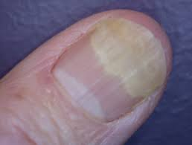
Onychorrhexis | Onychorrhexis causes ridges and splitting in your nails. Your nails may have several splits that cause triangle tears on the edges. Onychorrhexis involves the nail matrix, which is responsible for making your nail grow. While the nails are brittle, treatment is not contraindicated.  Conditions like onychorrhexis are rewarding to nail techs because we specialise in beautification. We can beautify nails that are split and ridged by performing a natural nail manicure or pedicure. If your client has no health condition and their cuticles are not compromised from a skin problem, do your magic. Enhancements are no danger to clients with onychorrhexis, and the difference in the appearance of her nails after a visit to your salon will earn you a loyal, grateful client. Keep in mind whatever is causing the nails to split — the nails in solvents or constant keyboard tapping, for example — may mean that the enhancements will take more of a beating. | 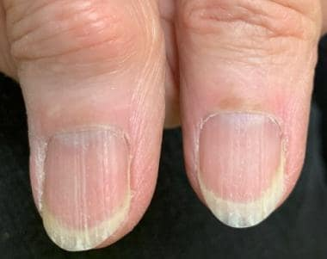
Onychotrophia | Onychatrophia is a very common nail disorder. Onychatrophia is an atrophy or wasting away of the nail plate, which causes it to lose its lustre, become smaller and sometimes shed entirely. Injury or disease may account for this irregularity. Onychatrophia can affect the fingernail or the toenails.  Because many people are unfamiliar with onychatrophia, the condition can be confused by the casual observer with a fungus. While it’s tempting to imagine all the ways enhancements could improve the look of atrophied nails, doctors caution against applying the product over the damaged area if there is no more nail. If some of the nail remains and it is clean, free from infection, and sturdy enough to hold an enhancement, you may be able to work with the client and a dermatologist to come up with a compromise on ways to beautify the nail. | 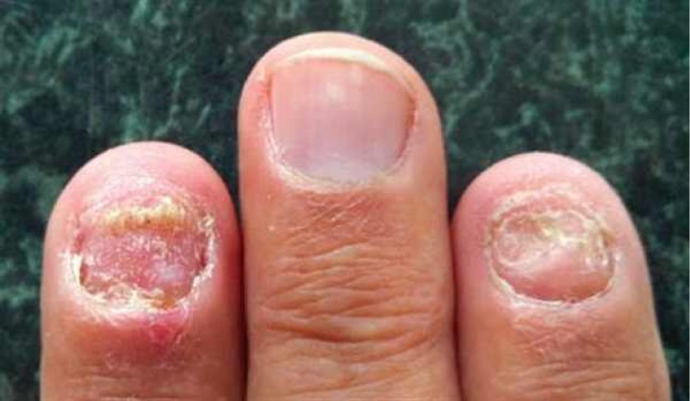
Pterygium | Pterygium is a nail abnormality that is either dorsal or ventral depending on the site of involvement. Dorsal pterygium occurs when the proximal nail folds fuse with the underlying matrix and, subsequently, with the nail bed. You can best identify pterygium on a client by studying photos of the disease to get acquainted with the triangular, winged shape of the skin that grows into the nail plate. If you suspect a client has pterygium, you should proceed with caution.  Polish and acrylic products are considered safe to apply but are not advised, as the product will be applied directly on the skin. This presents two problems: one, the product will have difficulty adhering to the skin; two, nail product should never be applied to the skin because it is an allergen and could cause a reaction. If you feel comfortable providing services to clients with pterygium, you should simply manicure the section of the nail plate that has not been compromised with pterygium, but avoid sanding down the nail plate, which is already weak. Strongly advise clients to schedule a doctor’s visit. | 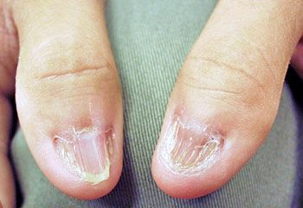
Splinter haemorrhage | A splinter haemorrhage is a longitudinal, red-brown haemorrhage under a nail and looks like a wood splinter. Splinter haemorrhages can develop after an injury or trauma to a fingernail or toenail. Stubbing a toe or injuring a finger can damage blood vessels along the nail bed and trigger bleeding. Before you begin working on the injured nail, ask your client what happened to it. Chances are they will tell you they injured it, but if they haven’t, advise them to get it checked out promptly. Filing, buffing, or handling a nail with a haemorrhage should be performed gently, so the underlying nail bed is not traumatised. | 