The table below outlines contraindications where you must refuse service, and a brief description as to why they are deemed as such. This website has over 100 contraindications for manicures and pedicures, so you may like to do more research if you come across a contraindication you are unsure of Contraindications A-Z
Contraindication | Overview | Example
Abnormal skin around the nail | Abnormalities such as spots, discolouration, and nail separation can result from injuries to the fingers and hands, viral warts (periungual warts), infections (onychomycosis), and some medications, such as those used for chemotherapy. Given it is not your role to diagnose skin conditions, if the skin is inflamed or discoloured, it is best to not perform services until the cause has been diagnosed and the skin has healed. | 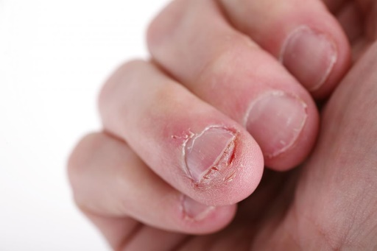
Allergic reactions | An allergy to nail and/or skincare products develops in stages through a process called sensitization, the result of prolonged or repeated exposure to a particular substance over days or weeks. Ultimately the skin’s natural protective barrier is breached, enabling that substance to combine with skin proteins and be carried via white blood cells through the body. Symptoms we commonly see with skin allergies are generally referred to as atopic dermatitis or eczema. Allergic reactions tend to escalate, so if you have a client who is allergic, it is best to refuse treatment. It is always best to err on the side of caution, as an extreme allergic reaction is just not worth the risk! | 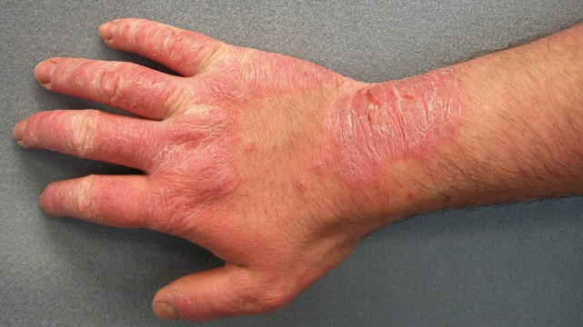
Bacterial, fungal, parasitic and viral infections (pseudomonas) | Green nail syndrome is caused by infection with Pseudomonas aeruginosa. This infection is caused by pseudomonas bacteria, which live silently under many nails minding their own business. This bacteria grows under a nail that has partially separated from the nail bed, thereby producing a green pigment. No antibiotics are needed.  Given bacterial, fungal and viral infections can look similar, it is best to refuse treatment until the nail or skin has healed. It is not worth the risk of exposing healthy clients to a potential condition by servicing clients with these types of problems. To learn more about bacterial, fungal, parasitic and viral infections, access the articles linked:  - Fungal Nail Infection  - Bacterial Nail Infections  - Parasitic infections  - Hand, foot and mouth disease | Pseudomonas  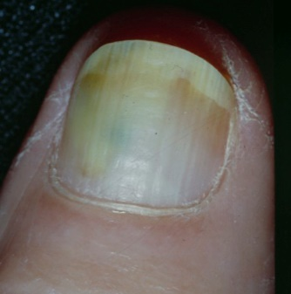  Fungal nail  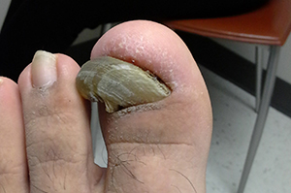
Bruising or swelling around the nail | A subungual hematoma is a transient condition where blood and fluid collect underneath the fingernail or toenail. This is usually caused by a traumatic injury as hitting your thumb with a hammer or stubbing a toe. With a subungual hematoma, the pain typically goes away in a few days. The nail itself will take longer to recover.  If bruising or swelling is apparent, it is best to wait until the clients nail or surrounding nail has healed. | 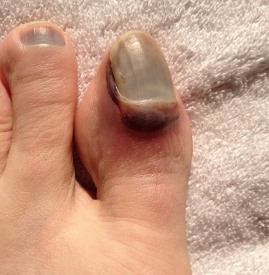
Contraindications of products used in combination or with other services | There may be times where clients have allergies with particular ingredients in products or may have other contraindications that relate to a combination of services. Of course, whether or not the service can be provided will depend on the individual circumstances. As an example, if your client is allergic to an ingredient used in gel nail applications or polish, you might be able to find an alternative. Always manage these types of clients with care as you do not want to cause reactions unnecessarily. If in doubt, patch test! | 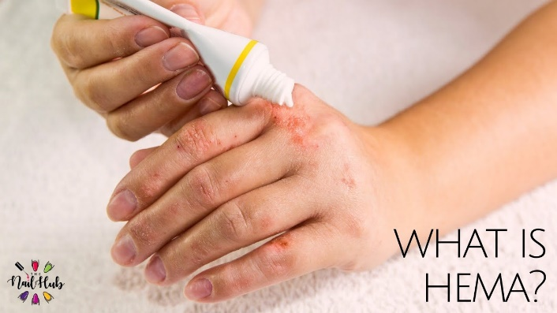
Damaged natural nails | Non-contagious contraindication such as onychorrhexis, onychotrophia, and eggshell nails can still be serviced. Whether or not you refuse service depends on the type of damage and the severity of the damage. You will need to make a determination depending on each client's individual circumstances. | 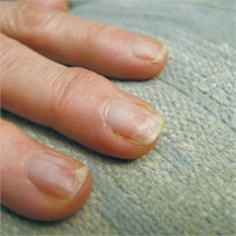
Dermatophytes Fungus | Fungal infection of the toenails or fingernails is a superficial fungus infection (dermatophytosis). The infection is caused by a fungal microbe that invades the nail bed. Fungal nail infection is also termed onychomycosis and tinea unguium.  A severe case of nail fungus can be painful and may cause permanent damage to the nails. It may lead to other serious infections that spread beyond the feet if the client has a suppressed immune system due to medication, diabetes or other conditions.  Not all fungal infections are contagious; however, onychomycosis and tinea unguium are. To protect yourself and your clients, you must refuse service. | 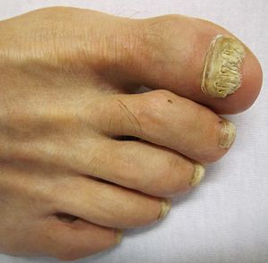  onychomycosis
Recent fractures, sprains and/or operations | Where a client has had a recent fracture, sprain or operation, it is important that you do not provide any services as there is a higher risk of infection. Even if you are super careful, it is just not worth the risk! Additionally, working around casts or slings can cause you to injure yourself in the process, so it is better to wait until the client is healed. | 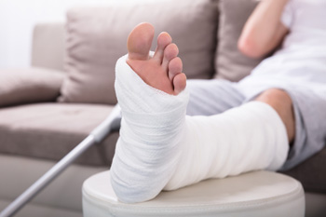
Subungual Melanoma | Subungual melanoma is a type of melanoma in the nails. Unlike other types of nail melanoma that grow in the surrounding skin, this type begins in the nail matrix. The nail matrix is a part of the nail bed that protects the underlying skin.  While subungual melanoma is a relatively rare condition compared to other skin cancers, it can lead to serious complications. Early detection and treatment is a must. Symptoms of this condition include:  - a light- to a dark-brown coloured band on the nail that’s usually vertical  - a dark band on the nail that slowly expands and covers more of the nail  - dark nail pigmentation that expands to the surrounding skin  - a nodule underneath the nail with or without a pigmentation band  - nail brittleness and cracking  - bleeding at the site of pigmentation  If you notice any of the above symptoms, DO NOT cover the nail or do any treatments. Strongly recommend your client seek advice from a professional. | 